**Hypothesis Testing**

Start with Hypothesis about a Population Parameter

Collect Sample Information

Reject/Do Not Reject Hypothesis

|  |  |  |
| --- | --- | --- |
|  | Ho is TRUE | H1 is TRUE |
| Fail to Reject Ho | Right Decision  Confidence  1-alpha | Type II error  beta |
| Reject Ho | Type I error  alpha | Right Decision  Power  1-beta |

The factors that affect the power of a test include sample size, effect size, population variability, and $α$.Power and $α$ are related as increasing $α$ decreases $β.$ Since power is calculated by 1 minus $β$, if you increase $α$,You also increase the power of a test. The maximum power a test can have is 1, whereas the minimum value is 0.

**Slide - 48**

**Hypothesis testing case studies exercise:**

Write Null and alternate Hypothesis for the following case studies:

1. Our quality will not improve after the consulting project
2. The retail market will grow by 50% in the next 5 years
3. We will acquire 8,000 new customers if I open a store in this area
4. Less than 5% clients will default on their loans
5. We will need 400 more person hours to finish this project
6. Our potential customers do not spend more than 60 minutes on the web every day

**Slide-49**

Different tests based on type of input and output data types and number of data types:

|  |  |  |
| --- | --- | --- |
| Y | X | Test |
| Continuous | Discrete in 2 categories | 2 - Sample t test |
| Continuous | Discrete more than 2 categories | ANOVA – One Way |
| Discrete | Discrete in 2 categories | 2 - Proportion test |
| Discrete | Discrete more than 2 categories | Chi-square test |

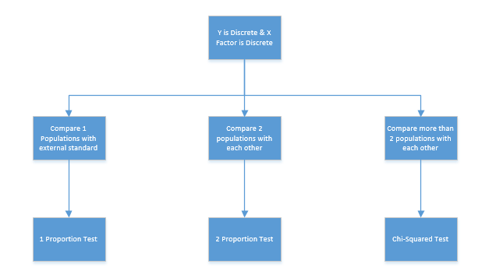

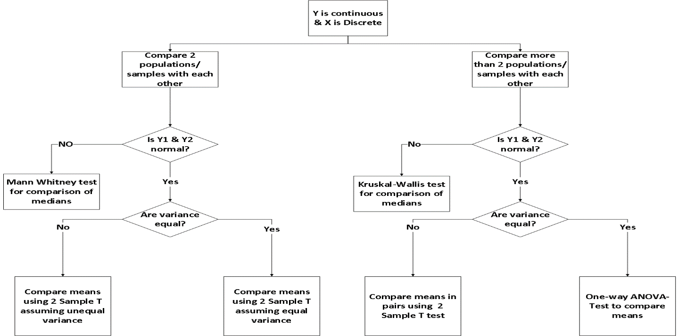

**2-Sample t-Test**

* Normality test

*Stat > Basic Statistics > Graphical Summary*

* 2 Variance Test

*Stat > Basic Statistics > 2 Variance*

* 2 sample t- Test

*Stat > Basic Statistics > 2 sample t*

***Marketing Strategy : case study***

A financial analyst at a Financial institute wants to evaluate a recent credit card promotion. After this promotion, 450 cardholders were randomly selected. Half received an ad promoting a full waiver of interest rate on purchases made over the next three months, and half received a standard Christmas advertisement. Did the ad promoting full interest rate waiver, increase purchases?

**2-Sample t Test – Write Hypothesis**

* Normality test

**Ho - Data are normal**

**Ha – Data are not normal**

* 2 Variance Test

**Ho – Equal Variance**

**Ha – Unequal Variance**

**2 sample t- Test *Stat > Basic Statistics > 2 sample t***

*Ho – Equal means*

*Ha – Unequal means*

***If Unequal means***

*Ho – Mean of Interest due to Standard Christmas advertisement is > Mean of interest due to Full interest rate wavier – Take no action*

*Ha – Mean of Interest due to Full Interest rate wavier > Mean of interest due to Standard Christmas advertisement – Take action*

**One way Anova Test:**

*Stat > ANOVA > One-Way….*

***Contract Renewal: Case Study***

*A marketing organization outsources their back-office operations to three different suppliers. The contracts are up for renewal and the CMO wants to determine whether they should renew contracts with all suppliers or any specific supplier. CMO want to renew the contract of supplier with the least transaction time. CMO will renew all contracts if the performance of all suppliers is similar.*

Normality Test:

Ho – Data are Normally Distributed (p-value >0.05)

Ha – Data are not Normally Distributed (p-value<0.05)

Variance Test:

Ho – Equal Variances (p-value >0.05)

Ha – unequal Variances (p-value<0.05)

Equal Means:

Ho – Means of all groups are equal (P-value > 0.05) – Take no Action

Ha – At least one group mean is different (p-Value<0.05) - Take Action

**2 Proportion T Test:**

**Johnnie Talkers : case study**

Johnnie Talkers soft drinks division sales manager has been planning to launch a new sales incentive program for their sales executives. The sales executives felt that adults (>40 yrs) won’t buy, children will & hence requested sales manager not to launch the program. Analyze the data & determine whether there is evidence at 5% significance level to support the hypothesis

Ho – Proportion of A = Proportion of B

Ha – unequal Proportions

If Unequal Proportions

Ho – Proportion of Children buying ice cream > Proportion of Adults buying ice cream

Ha – Proportion of Adults buying ice cream > Proportion of Children buying ice cream

**Chi-Square Test:**

Case Study:

Baha ManTech Research Company uses 4 regional centers in South Asia (India, China, Srilanka and Bangladesh) to input data of ques5onnaire responses. They audit a certain % of the ques5onnaire responses versus data entry. Any error in data entry renders it defec5ve. The chief data Scientist wants to check whether the defec5ve % varies by country. Analyze the data at 5% significance level and help the manager draw appropriate inferences. [‘1’ means not defec5ves & ‘0’ means defective]

Ho – All Proportions are equal

Ha – Unequal Proportions